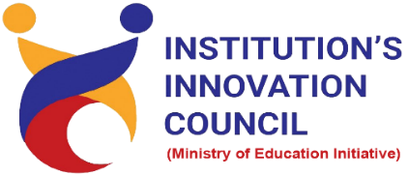
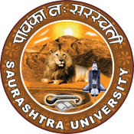

Our Environment in Last 50 years

24 June 2022
At
Seminar hall, Department of Biosciences
Saurashtra University Campus, Rajkot
Contents
Saurashtra University – IIC 2
Event Schedule 2
Event Registration Link 2
Brief about Event 3
Key Points 3
Outcome 3
About the Speaker/Chief Guest 4
Connect Us: 6

Saurashtra University – IIC
The university is dedicated to instruction, research, and extending knowledge to the public (public service). Ministry of Education (MoE), Govt. of India has established ‘MoE’s Innovation Cell (MIC)’ to systematically foster the culture of Innovation among all Higher Education Institutions (HEIs). The primary mandate of MIC is to encourage, inspire and nurture young students by supporting them to work with new ideas and transform them into prototypes while they are informative years. Saurashtra University is one the Organization that have constituted the IIC to foster the vision of MoE and be a part for the promotion and development of innovation ecosystem.

Event Schedule

Event Registration Link

bit.ly/WED-SUIIC

Brief about Event

We had celebrated World Environment Day- 24 June 2022 by organizing a session on "Our Environment in Last 50 years". Students of Saurashtra University from department of biosciences participated and celebrated world environmental day enthusiastically.

The session was focus on: How our environment is concerned and how it has been affected by Human Beings in last 50 years and to give broad idea about current situation of Environment. This was an exclusive event for raise global awareness to take positive environmental action to protect nature and the planet earth.
The aim behind organizing this workshop was to give awareness to Student about keeping the environment clean and safe from pollution. For this purpose, plant more trees to purify the air and make the earth green. Due to climate changes these are the sectors which will be affected most like people who is low-income communities affected the most, older people will be affected the most, children would be affected most understood by the speaker.

Key Points

During the session, below mentioned points were discussed:
- What is environment
- What is climate
- Earth summit-1992
- Agenda -21
- Ice ages
- Temperatures increased over the past century
- Earth present carbon dioxide level
- Top environmental issues
- FAQs related to Our Environment in Last 50 years

Outcome

As per the event, various types of environmental issues and how the temperature rises were understood by the speaker. Students learn a lot about how to protect our environment and what are the solution for keeping safe our environment. Student learn about the 10 warmest years on record have occurred since 2005.

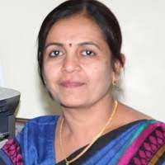
About the Speaker/Chief Guest

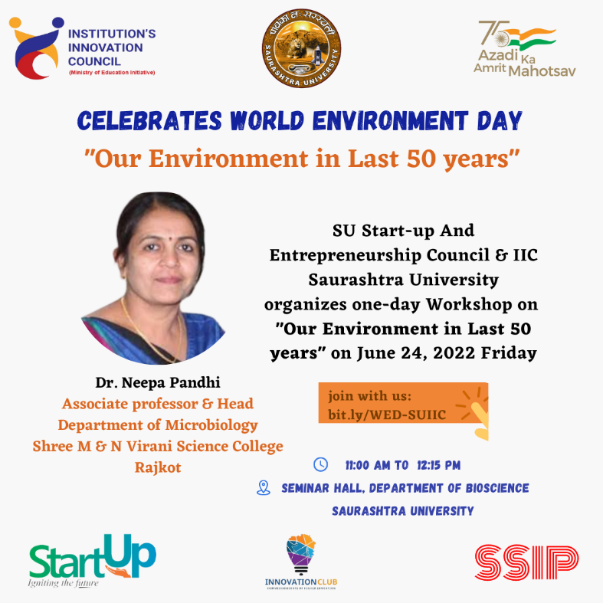

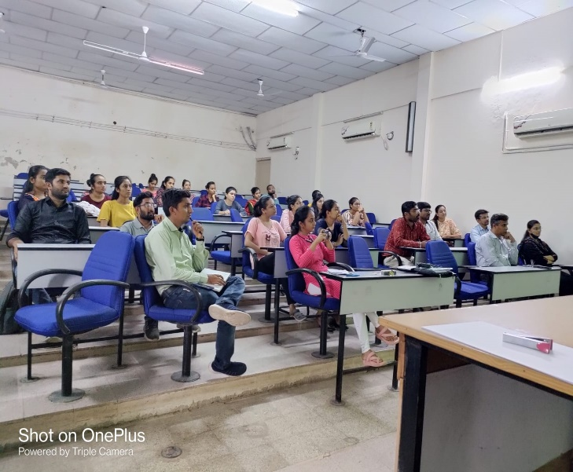
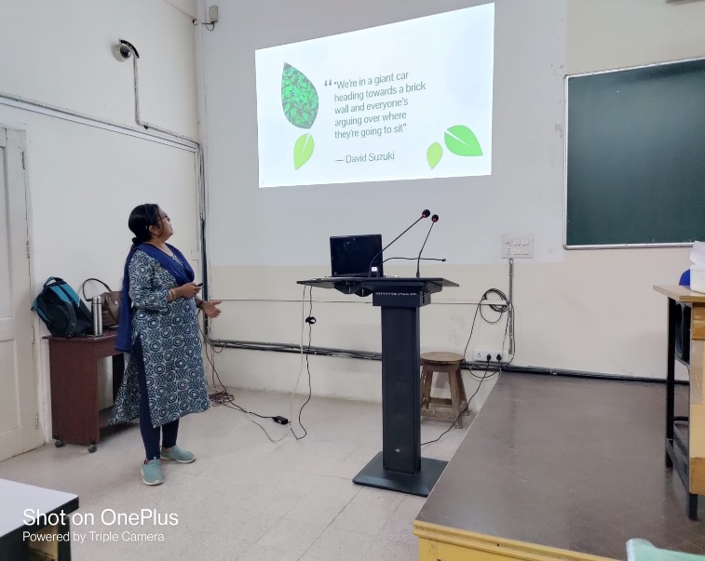

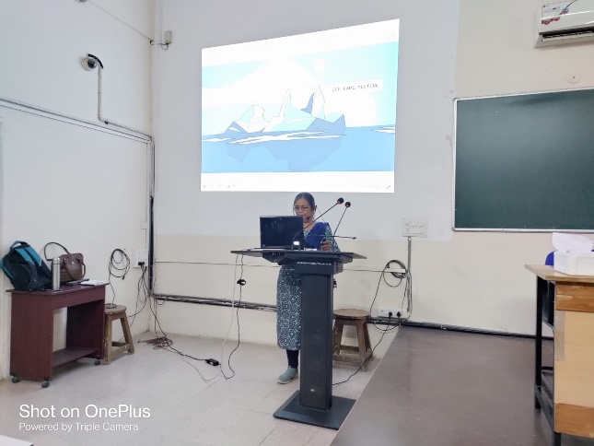
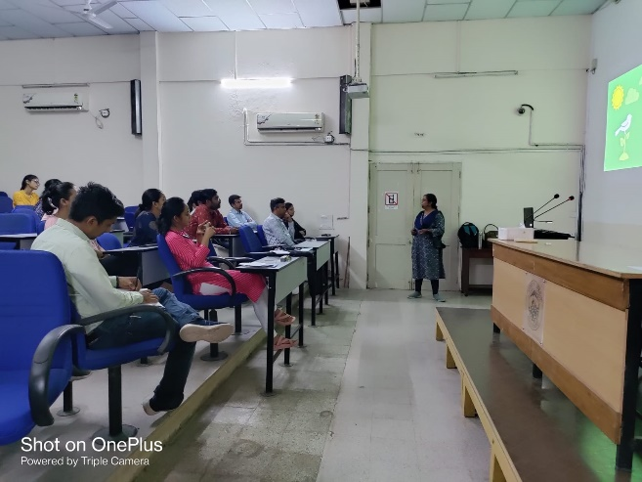
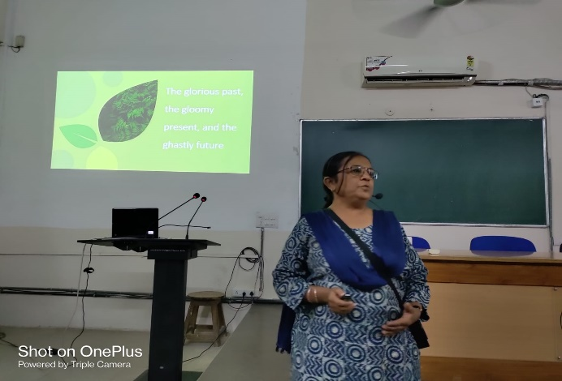
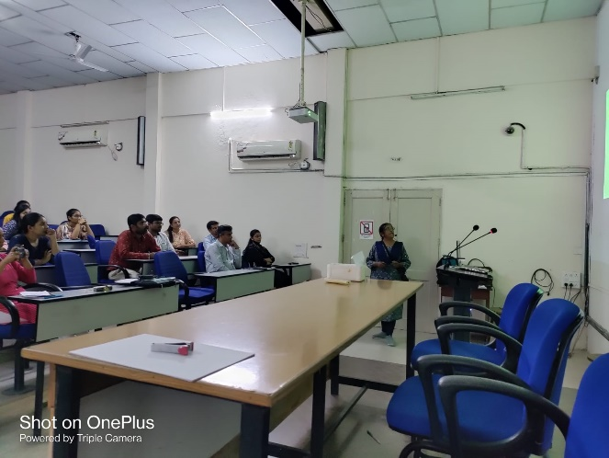

Connect Us:

https://www.linkedin.com/company/susec iic@sauuni.ac.in
https://www.facebook.com/iicsauuni bit.ly/SU-SSIP Location
https://www.instagram.com/susecrajkot https://bit.ly/SUSEC-youtube

